TITLE OF THE ARTICLE

A. POPESCU M. SMITH

Abstract: The abstract should concisely summarize the key elements of the paper in a clear, coherent and self-contained manner. It must begin with a statement of the paper’s purpose and end with the main findings and conclusions. Authors are required to use short, direct, and complete sentences, structured in a single paragraph, without indentation or tabs. The abstract should be 7 to 10 lines in length, offering readers a quick overview of the paper’s relevance and originality.

Key words: 3 to 6 significant key words.

1. Introduction

The full paper, including tables, figures, references, and appendices, must be between 2,000 and 6,000 words, with the final page filled at least 70% to ensure balanced formatting.
Each participant may submit only one paper as first author or co-author within the conference volume.
Papers must be written in English only, using Microsoft Word and the Calibri font. Authors are strongly advised to use the official EARTH 2025 template, and to insert their content directly into the provided file to maintain consistent formatting across all submissions.

2. Instructions for Editing

2.1. Format of the Papers

An A4 (210 mm x 297 mm) format will be used. The limits of the printing zone: margins: top - 5 cm, left, right and bottom - 3.5 cm; heading - 4 cm; foot margin - 0 cm.

3. Arranging the Text within the Page

Title of the paper - Calibri 18 pt. capital letters, bold, centred, 1 cm left indentation, single spacing.
Leave a blank line (18 pt.) under the title.

Author(s) - Calibri 14 pt., bold, centred, 1 cm left indentation, (single spacing:
- first name “title case” and surname in capital letters, when there is a single author (e.g. Andreea POPESCU);
- initial(s) of every author’s first name and surname, in capital letters; they will not be separated by a comma and may be written on two lines unless they fit within a single one.
Leave a blank line (18 pt.) between the authors’ names and the abstract.

Authors’ affiliation - Calibri 9 pt., regular, justified, on one line.
The full affiliation (groups, laboratories and institutions) of each author will be specified as a reference in the footnote (Insert Reference, Footnote, Bottom of page); the affiliation for each author will be marked with Arabic numerals. If several authors are part of the same organization, then its name may be written once and the authors will be marked with the same number. ORCID ID for each author is also required.

Abstract - Calibri 12 pt., italic, bold; body text of the abstract of the paper: Calibri 10 pt., italic, regular, justified left-right (justify) along the page, single spacing.
The abstract of the paper will consist of 7 to 10 lines, with 2 cm left, 1 cm right justified.
Leave an empty line (10 pt.) between the abstract and the key words.

Key words - Calibri 12 pt., italic, bold; 3 to 6 significant key words (or groups of words): Calibri 10 pt., italic, regular, 2 cm left, 1 cm right justified, single spacing.
Leave two empty lines (2 ×10 pt.) between the key words and the text of the article.

Text chapter - Calibri 11 pt., bold, “Title case”, left justified, 0 indentation, single spacing, 0.4 cm hanging.
The titles of the chapters are successively numbered in Arabic numerals, followed by a full stop and a space.
Sections Acknowledgements and References will not be numbered.
Above and below Text chapter, leave an empty line (11 pt.).

Text subchapter - Calibri 11 pt., bold, “Sentence case” left justified, 0 indentation, single spacing, 0.7 cm hanging.
The number of the subchapter includes the number of the main chapter, full stop, the number of the subchapter, full stop and a space.

Main text - Calibri 11 pt., regular, justified, single spacing. The first line of every paragraph will be indented at 0.3 cm.

3.1. Other Data with Reference to Drawing up the Content of the Paper

Articles should be reasonably divided into chapters and, if necessary, into subchapters, for example: Introduction, Objectives, Material and Methods, Results, Conclusions and Discussion, Acknowledgements, References.

• Tables and Figures

Figures (drawings, diagrams, images) and tables will be included in the order they appear in the text, and will be centred. Figures (high quality) will be placed as close as possible to where they are first mentioned in the text.
The text explaining the figure (the caption), placed under the figure (Calibri 11, italic, centred, spacing 6 pt. before, on one line), will be preceded by „Fig.” followed by a space, the number of the figure (Arabic numerals), full stop and space (Calibri 11 pt., regular) as in the examples for Figures 1 and 2.

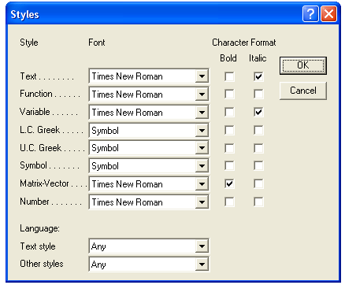
Fig. 1. Drawing inserted within the text

Within the text, the references to the figure (table) will be made by writing Figure x (Table x), within the sentence. The texts within the figures (in English, German or French) will be of a size that should ensure good readability.
Blurred figures will not be accepted.

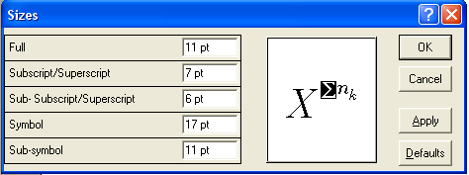
Fig. 2. Image of ...

Tables (numbered in Arabic numerals) will be placed in the text as close as possible to where they were first mentioned. The size of the font used for tables is Calibri 10 pt., regular (Table 1). For bigger tables, Calibri 9 pt. may also be used.
Measurement units will be placed within square brackets, at the top of the table.

Caption for the table Table 1
Efficiency [%] | 94.37 | 96.58 | 93.18 | 83.66 | 75.30
… | … | … | … | … | …
… | … | … | … | … | …
… | … | … | … | … | …

Tables captions will be placed above the table (Calibri 11, italic, centred, spacing 6 pt. afterwards, on a single line, followed by „Table x” (Calibri 11, regular, right justified).
Page long tables are advised. In exceptional cases, landscape-oriented tables are advised. For tables and figures from the literature, the source must be quoted.

Acknowledgements

This short section will be placed right before References and the heading Acknowledgements will have the format of the chapter title without a number. The acknowledgements may be addressed to the persons or to the institutions that are not mentioned elsewhere in the text and that played an important role in obtaining the results discussed in the paper.

References

References will be written after the last chapter. The word References will be formatted as the title of the chapter and will not be numbered.
The conference requires the Harvard referencing style, developed by Anglia Ruskin University. The referencing style can be accessed at the following link: http://libweb.anglia.ac.uk/referencing/harvard.htm. If a DOI has been assigned to the journal articles that are cited, author(s) should include it after the page number for the article.
References should be listed first alphabetically and then chronologically. The section should include all and only references that are actually mentioned in the text.

• Other Specifications

The entire responsibility for the content of the paper pertains to the author. The author has to obtain the right to make use of any material under copyright laws.
Personal opinions presented in the published articles pertain to the author and not to the members of the Editorial Board of the conference.
Each author is fully responsible for the linguistic quality of their submitted paper. A high level of academic English is required, and all manuscripts must be carefully edited prior to submission. If reviewers or members of the Editorial Board consider that the English language quality does not meet the expected standards, authors will be required to revise and improve the text accordingly.
While the peer-review process is conducted by the Editorial Board and the scientific reviewers, language supervision is not provided by the organizers.

Further information may be obtained by writing to the address: earth@unitbv.ro

Transilvania University of Braşov, a.popescu@unitbv.ro, ORCID ID
Affiliation of the second author.

